The 3rd Imperium

The Imperium is a far-flung interstellar state encompassing over 11,000 worlds in 9,000 systems within a region approximately 700 parsecs across. It is divided into sectors 32 parsecs by 40 parsecs in size. Each sector is divided into 16 subsectors (8 by 10 parsecs). And within each subsector are perhaps 30 or 40 star systems.
The Imperium is governed by a three-tier system. Individual systems are free to manage themselves as they desire within a loose framework provided by the Imperium. Interstellar government begins at the subsector level. Each subsector constitutes an Imperial duchy, ruled over by an Imperial duke owing fealty to the Emperor. Many of the Imperium’s functions are managed at the duchy level. What people refer to as Imperial laws are actually often enacted on the duchy level and may not apply in the neighboring duchy (although in many cases the dukes do pay attention to what their fellow dukes do and the Imperial High Laws and various Imperial edicts do provide a lot of similarity). Where a larger scope is needed, the Emperor turns to his ministries and to the Imperial armed forces. The result is a tripartite administration situation somewhat akin to the dual system of state and federal governments of that Old Earth region known as the U.S.A., although thanks to communications delays, the duchies are in a stronger position vis-à-vis the ministries than the U.S. states were vis-à-vis the federal government. Jurisdictional disputes between Imperial and duchy organizations with similar duties are not uncommon. The relationship between the individual systems and the duchy governments and their relative power vary a lot from duchy to duchy.
In some cases Imperial administration is organized at two other levels: the sector and the domain. At the sector level one of the sector’s dukes has certain supervisory duties. He is known as the sector duke, but is nevertheless merely first among equals; the sector’s other dukes do not owe him fealty. There are no legislative functions at the sector level. A domain is a group of four sectors and is presided over by an archduke. The archdukes lost their actual powers centuries ago, but for a while now, Emperor Strephon has been reviving the domain as an administrative unit and transferred many of the sector functions to the domain, thereby reviving the powers of the archdukes.
The X-boat Network: The Imperium is covered by a network of express courier ships. Each is capable of jump-4 (four parsecs in a week). Along a few select backbone routes ships capable of jump-6 are used. All sector and subsector capitals plus a number of other important worlds are linked by these ships.
Companies and megacorporations: Any company that wishes to engage in interstellar commerce must have an Imperial charter to do so. In exchange the Emperor gets 2% of the company’s stock. Many companies only trade between a few worlds. Some cover an entire duchy. A couple of hundreds cover a whole sector. And only 13, the so-called megacorporations, cover the entire Imperium. These organizations are so large that no one person can know everything they are concerned with at any given moment. Total shares of stock, annual profits, number of employees are all astronomical. In many cases, the organizations are so large that different divisions of the same megacorporation may actually be working at cross purposes.
The Ancients

The Ancients were a highly advanced race which dominated this part of the galaxy some 300,000 years ago.
Most of what is known about the Ancients has been gleaned from archeological excavations of Ancient sites: the remains of cities, bases, outposts, and settlements of the Ancients. All datable Ancient remains seem to belong to a period from around -310,000 to -290,000. Towards the end of that period a cataclysmic war spanning perhaps 2,000 years – the so-called “Final War” – destroyed virtually all Ancient structures and if any Ancients survived, no one has been able to find any traces of them.
What everybody knows about the Ancients:
• They visited Terra numerous times and transported populations of Homo sapiens antiquus to somewhere around a hundred other worlds. After the Final War these groups were left to fend for themselves. Imperial scientists know of 48 surviving populations descended from such groups (49 counting the Solomani (the people of Terra), and there may well be others beyond Charted Space. Three of these Human subspecies – the Solomani, the Vilani, and the Zhodani – invented jump drive independently and went on to found great star-spanning empires.
• They similarly scattered the Droyne (an alien race) across many different worlds, but none of these Droyne populations ever amounted to much; they are usually content to stay on their home worlds.
• They genetically manipulated Terran canine stock to create the Vargr, a bipedal sapient race that invented jump drive independently and spread across part of Charted Space corewards of the Imperium.
• They moved around flora and fauna from Terra and the Droyne homeworld (Eskaloyt) on a grand scale and from other worlds on a lesser scale. Examples of one biosphere can often be found on several other worlds (In the case of the Terran and Eskaloytan biospheres on hundreds).
• They moved around whole worlds and messed with atmospheres and hydrospheres, in many cases making them more comfortable for Humans (and Droyne, and Vargr) – presumably as a side effect of making them more comfortable for themselves, but who knows? In other cases they made changes that seem altogether incomprehensible. And the Final War created a lot of asteroid belts...
• They left behind artifacts that remain functional even after 300,000 years and are based on incomprehensible technological principles. The Imperium has declared all Ancient artifacts Imperial property (Though it may, after thorough investigation, allow museums and private citizens to own useless ones). It pays a sizable finder’s fee to anyone who turns over an Ancient artifact and may punish with fines or imprisonment anyone who is caught in possession of an unregistered one. Incidentally, 99 out of 100 Ancient artifacts are fakes.
• No one actually knows what the Ancients looked like. One theory is that the Droyne are degenerate descendants of the Ancients. Another theory is that the Ancients were Humans. A third is that they were beings of pure thought. There are dozens of other theories naming this or that alien race the degenerate descendents of the Ancients. Some even think they were more than one race.
The Duchy of Regina

Regina is an oversized duchy on the Imperial border, 35 weeks from Capital by X-boat, a year or more by commercial transport. In addition to the Regina subsector, the duchy also includes the Imperial part of the Jewell subsector and two systems in the Aramis subsector. The duchy’s capital, Atora, is located on the world Regina in the Regina system. The duke is Norris Aella Aledon who was elevated to archduke of the Domain of Deneb four years ago. This has given the duchy’s lesser nobles itchy ambitions, as the Emperor is expected to give Norris’ ducal title to one of the local counts eventually. At the moment Norris’ ducal duties are being carried out by Countess Josephine of Efate while he is governing Deneb Domain from Mora, the capital of both the Duchy of Mora, the Spinward Marches sector, and the domain. Meanwhile Count Evan of Roup, Countess Ursula of Rethe and Count Salak of Jewell is jealously watching her every move.
The duchy is a bit of a technological backwater, unable to produce the most advanced Imperial equipment itself, although such equipment can be imported from the Duchy of Rhylanor.

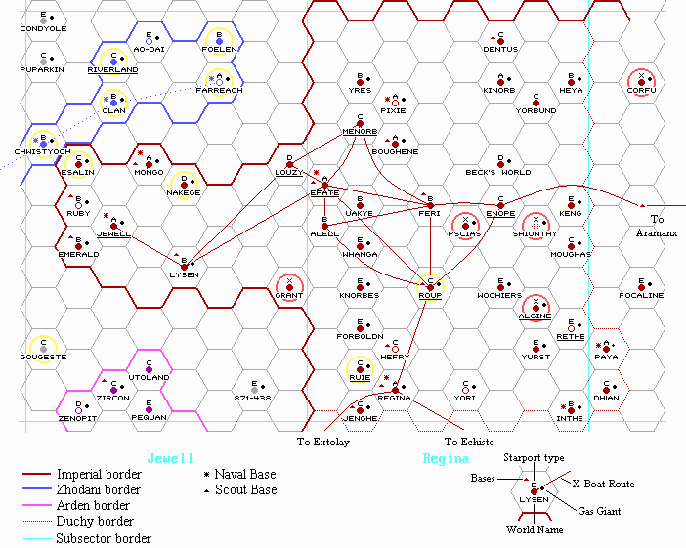
Regina: Coming and Going

Theoretically everyone who crosses the extrality line into and out of Credo Down Starport is registered with both the Imperial Starport Authority (SPA) and with one or more Reginan authorities. The SPA files are restricted, but not very much. Anyone working for any Imperial organization –– Army, Navy, Marines, Scouts, Ministry of Justice, Colonial Office, etc. –– can access them, and former members of such organizations just need someone active to sign off on it (any non-negative reaction roll will do). Some private agencies make it a habit to procure copies of these files, and anyone who manages a Streetwise roll can find someone who will allow them to search the files at a cost of 10 Reginan crowns per name.
The first time someone comes to Regina, he is registered with the Reginan Immigration Office and issued a Reginan identity number and a basic computer account with the Central Data Banks. He gives a name when he arrives and gets a com-code assigned. This is free (Any extras cost money, but not very much). It is possible to give an alias, but if one wants to transact business with local companies, showing an Imperial identity card is a distinct plus.
After that, there is no central registry of who is on Regina and who is not. Some people notify the Reginan Communication Bureau when they go off-planet, usually to arrange for messages to be forwarded. Anyone making a call to such a person will be notified that he is offworld at the moment. Of course, there is nothing to prevent anyone from notifying the RCB and then staying on Regina after all, or from failing to notify them when he returns.
The chief source of inaccuracies comes from the fact that Regina High isn’t just used as an Imperial starport but also as a spaceport serving the rest of the Regina system. Anyone going to another planet or station in the system and then going down on Regina via one of the secondary Reginan spaceports will arrive without being registered by the SPA. Likewise it is possible to go from such a spaceport to Regina High and depart the system without being registered. Such people will usually appear in some Reginan registry, but Reginan administration is both inefficient and corrupt, so errors, accidental or a-purpose, are not unknown.
Incidentally, SPA does not track people who arrive in and leave the system by starship either. The individual passenger lines keep records, but there are many small lines and if someone travels by Free Trader, there will usually be no record at all.
Regina: Anonymity

Surveillance and record-keeping is a constant struggle between two mutually incompatible desires: To ensure that your neighbor can’t do things you don’t want him to do, and to make sure your neighbor can’t stick his nose into your private affairs! Reginan law is descended from Terran Confederation law and embodies such concepts as right to privacy and freedom of the individual. The government is, however, rather invasive, and routinely violates the spirit (and often the letter) of the law. The government can’t bust you for protecting your privacy, but it can do its best to make you fail against its own surveillance efforts.
Lots of Reginans prefer that their comings and goings are not subject to too much public scrutiny, so databases are often restricted and people routinely wear cloaks or clothing belts that obscure their features. Actual masks are, however, illegal, except for theatrical purposes, where they require a license. TL10 theatrical masks made of faux-skin are amazingly lifelike and make it child’s play to disguise oneself. To disguise oneself as a particular person is much trickier. It requires that one’s size, build, and face are just the right fit. Even if size and build it right, there is still only about a 2% chance that any random person can disguise himself as any specific person (throw 3 or 4 on 3D).
Holo-belts (UT86) are illegal. They cost Crimp430 (700 crowns) plus whatever extra it takes to get an illegal imported item on the black market. Holocrystals with images costs Crimp40 (64 crowns) apiece. Images are lifelike, but static. A holo-belt capable of projecting a lifelike moving image (making it able to disguise someone as a living creature) costs Crimp750 (1,200 crowns) and weighs 4.5 pounds.
Clothing Belts (UT27) are legal. They mount a smaller and less capable holoprojector than holobelts do, so the image is often not quite lifelike, but they have a built-in computer that lets the user custom-design the image and makes it conform to a moving body. Cost is 1,000 Reginan crowns (CrImp625) and the weight is 2 pounds³.
Makeup can change skin color temporarily and pigmentation pills permanently (as long as one keeps taking the pills). Faux-skin gloves can easily duplicate fingerprints, while bioplas contact lenses can change eye color and fake retinal prints. Faking fingerprints and retinal prints is, of course, completely illegal.
The use of credit cards leaves an electronic trail, but one-use debit cards are available, and cash is, of course, almost always acceptable.
Even genetic evidence is not absolute. There exists a type of artificial virus called an anonymity virus designed to lie dormant in a person’s cells while it is alive, but to briefly activate and scramble a cell's genetic markers when it dies. The creation and sale of anonymity viruses is illegal on Regina, but carrying one is not, so the rich and powerful can go to Efate to get one. Such viruses are expensive; each one has to be tailored for the individual. There are rumors of an advanced version that can actually substitute a different genetic code. Something like that would be illegal to carry.
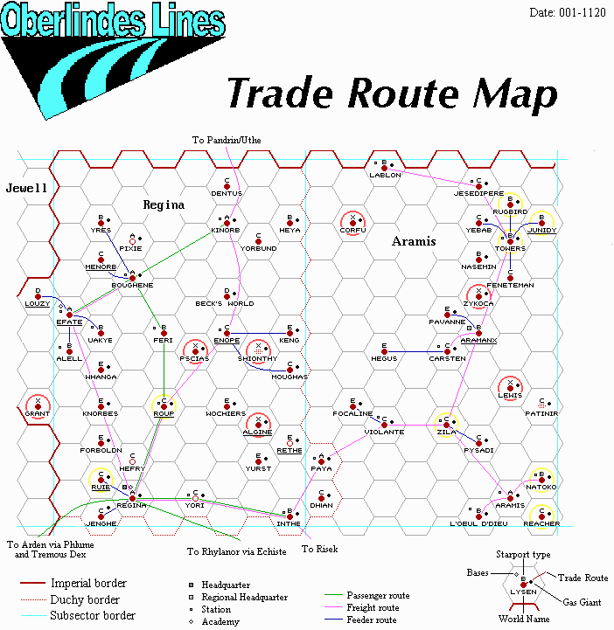

Yes, there is a dimension missing; the Traveller universe is apparently only one parsec thick. No, I don’t want to explain it or discuss it. Just don’t think about it.
Many Ancient materials defy analysis and cannot be properly dated.
Logically realistic masks should be legality class 4 (“Legitimate uses, but can make some types of crime easier”). For cultural reasons they are Class 5 on Regina.
Think Mission Impossible.
Note that clothing belts and holo-belts emit rather than reflect light, so they are very obvious in the dark.

